YEAR 12 CHEMISTRY - 3ACHE

TEST 1

Atomic Structure and Bonding, Solutions

Recommended time: 1 hour

Name: __Solutions______________________

Teacher: _____________________________________________________

This test is in three sections.

SECTION 1:Multiple choice style test consisting of 14 questions.
Each question is worth 1 mark.
Write your answers in the table provided.
Attempt ALL Questions

SECTION 2 & 3: Short Answer and Problem Solving questions
Write all answers in the spaces provided.
The marks allocated to each question are shown at the foot of each question.

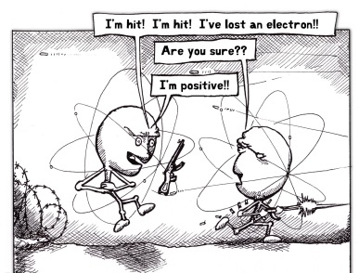

Another Casualty in the Wars of the Atoms

SECTION 1: Multiple Choice
Place your answer in the table below. This part is worth 14 marks.

1 | 2 | 3 | 4 | 5 | 6 | 7 | 8 | 9 | 10 | 11 | 12 | 13 | 14
B | B | D | B | D | C | B | D | A | D | A | C | C | D

- Which one of the following lists the correct number of protons, neutrons and electrons for the F⁷⁺ion?

Protons Neutrons Electrons

- 9 19 2
- 9 10 2
- 9 10 1
- 19 10 2

- The physical properties of solid metals can best be explained by proposing that:

- Each metal atom is bonded in the crystal lattice by covalent bonds.

- Positive metal ions are arranged in an orderly way, with valence electrons able to move freely through the crystal lattice.

- Positive and negative metal ions are arranged in an orderly way, with mobile valence electrons able to migrate easily around the crystal lattice.

- Each metal atom is surrounded by a variable number of valence electrons, which complete a ‘noble gas’ electronic structure in the crystal lattice.

- Which one of the following species does not have an electron configuration corresponding to an inert gas?

- C⁴⁻
- Sc³⁺
- Sb³⁻
- P⁴⁺

- An example of a non-polar molecule that contains polar covalent bonds is

- Dichloromethane (CH₂Cl₂)
- Sulfur trioxide, SO₃
- Water, H₂O
- Ammonia, NH₃
- The electron configuration for element X is (2, 8, 5) and Y is (2, 8, 7).

The most likely chemical formula for the covalent compound of X and Y is:

(a) X₃Y₂
(b) X₂Y₃
(c) XY
(d) XY₃

- Which of the compounds CH₃OH, BF₃, NH₃, and H₂S are highly soluble in water?

- CH₃OH only
- NH₃ and BF₃
(c) CH₃OH and NH₃
(d) CH₃OH, BF₃, NH₃, and H₂S

- In which of the following solid substances is there only one type of bonding between the particles?

- Aluminium hydroxide
- Barium oxide
- Calcium nitrate
- Graphite

- The force involving positive ions attracting the lone pairs of electrons on the oxygen atom of a water molecule is called a(n)?

- Dipole-dipole force
- Hydrogen bond
- Coordinate bond
- Ion-dipole force

9. The correct formula for the substance sodium dihydrogenphosphate is:

- NaH₂PO₄
- Na₂H₂PO₄
(c) Na(H₂PO₄)₂
- Na(HPO₄)₂

10. The table shows some properties of four solids, W, X, Y and Z.

Properties | W | X | Y | Z
Melting Point ºC | 2300 | 800 | 80 | 1200
Soluble in water | No | Yes | No | No
Solid state conducts electricity | No | No | No | Yes
Molten state conducts electricity | No | Yes | No | Yes
What is the correct classification of the solids?
 | Metallic | Covalent Network | Ionic | Covalent Molecular
(a) | X | W | Y | Z
(b) | Z | Y | X | W
(c) | X | Z | W | Y
(d) | Z | W | X | Y

- Which of the following statements is TRUE about trends in the periodic table?

  - Within group 16, as the atomic number decreases, the first ionisation energy increases.

  - The melting temperatures of group 17 elements are less at the bottom of the group than at the top.

  - The electronegativity of elements on the right hand side is less than those on the left hand side.

  - The further apart two elements are in the periodic table, the more likely they are to form a covalent bond between them.

- Which of the following statements correctly describe what occurs when liquid CH₂F₂ evaporates into a gaseous form?

I. Dispersion forces are overcome.
II. Dipole-dipole forces are overcome.
III. Hydrogen bonds are broken.

  - I only
  - II only
  - I and II only
  - I, II and III

- Two elements X and Y have the following successive molar ionisation energies:

IONISATION ENERGY (kJ mol⁻¹)

1st 2nd 3rd 4th

X 1080 2000 4100 8400

Y 500 4600 6900 9500

If the atomic number of element Y is greater than that of X by 2, then X is likely to
belong to which group of the periodic table?

- 1
- 2
- 17
- 18

- For the substances PH₃, F₂, LiBr, SiO₂ and AsH₃, which of the following correctly represents them in order from lowest to highest boiling point?

(a) PH₃, F₂, SiO₂, AsH₃, LiBr

(b) F₂, AsH₃,PH₃, LiBr, SiO₂

(c) AsH₃, F₂, PH₃, SiO₂, LiBr

(d) F₂, PH₃, AsH₃, LiBr, SiO₂

END OF SECTION 1
SECTION 2: Short Answers
Answer all questions in the space provided. This part is worth 18 marks.

1. Use the periodic table to write the chemical symbols for the following elements.

A The element that forms a (+3) ion, where the ion has an electron configuration of 2 8. Al
B An element from period three that forms a dioxide with oxygen. Sor Si
C The element from Group 1 with the largest atomic radius. Fr
D The most electronegative element in period 3 of the Periodic Table. Cl [4 marks]

2. Group the following liquid substances into appropriate columns below according to their dominant type of intermolecular forces that exist between their molecules.

{N₂, OBr₂, CCl₄, ClF, C₂H₅OH, HF}

Dispersion | Dipole - Dipole | Hydrogen Bonding
N₂  CCl₄ | OBr₂  ClF | C₂H₅OH  HF

[3 marks]

3. Using the axes provided, sketch a line graph to represent the relationship in EACH of the following: (part (b) is on the next page)

(a) The first ionisation energies of the alkali metals Li, Na, K, Rb and Cs.

First Ionisation
Energy
(kJ mol⁻¹)

Li Na K Rb Cs

(b) The boiling points of the hydrides of the group 17 elements

Boiling Point
(ºC)

HF HCl HBr HI

[2 marks]

4. Complete the following table: (N₂O has the atoms already positioned to help)

Molecule | Electron dot diagram  (show all valence electrons) | Sketch or name of molecular shape | Polarity of molecule  (polar or non-polar)
SO₂ | 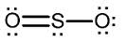 | V shaped/Bent | Polar
BF₂Br | 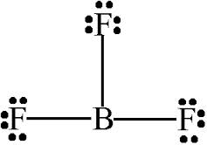  ..  Br :  .. | Triangular Planar | Polar
N₂O | .. ..  :N :: O : :N: | Linear | Non-Polar
Na₂SO₄ | [Na]⁺₂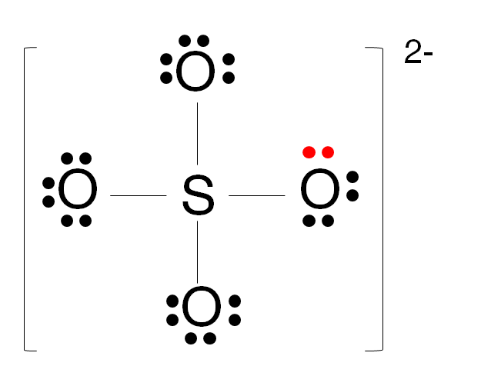

[5 marks]
5a. In an experiment to test the solubility level of iodine (I₂) in various liquids, some solid crystals of the chemical were added to 150mL of distilled water (H₂O) in a beaker. However, practically none of the iodine dissolved, and instead stayed as solid crystals on the bottom of the beaker.
Explain this observation using your knowledge of intermolecular forces and interactions between molecules. [2 marks]

( ) = optional; ______ = essential

Iodine (being non-polar) only has dispersion forces between its molecules. (½)
Water (being polar) predominantly has hydrogen bonds between its molecules. (½)
The only possible attraction between these 2 substances would be dispersion forces(½), which are not strong enough(½) to overcome the hydrogen bonds between water molecules.

5b. A second stage of this testing was then carried out whereby 150mL of another solvent called tetrachloromethane (CCl₄) was added to the water/iodine mixture. Upon addition, two distinct layers formed and the colour of the CCl₄ layer changed to indicate that the iodine had dissolved into it.
Explain this observation using your knowledge of intermolecular forces and interactions between molecules. [2 marks]

( ) = optional; ______ = essential

Iodine (being non-polar) only has dispersion forces between its molecules. (½)
Carbon tetrachloride (being non-polar) only has dispersion forces between its molecules. (½)
The only possible attraction between these 2 substances would be dispersion forces(½), which are strong enough/of equal strength (½) to overcome the dispersion forces between iodine molecules and between carbon tetrachloride molecules.
(the water and CCl₄ don’t mix for the same reason as in 5a)

END OF SECTION 2
SECTION 3: Problem solving-You must show working to gain full marks.
Answer all questions in the space provided. This part is worth 8 marks.

A solution of aluminium sulfate [Al₂(SO₄)₃] was prepared by dissolving 8.24g of the solid in a small volume of distilled water and the resultant solution made up to 250.0mL. The final solution had a mass of 257.8g.
Determine:

(a) the concentration of Al₂(SO₄)₃ solution in gL⁻¹. [1 mark]

C(Al₂(SO₄)₃) = m/V

= 8.24/0.250

= 33.0 gL⁻¹

(b) the concentration of Al₂(SO₄)₃ solution in molL⁻¹. [2 marks]

EITHER:

C(Al₂(SO₄)₃) = m/M

= 33.0/342.14

= 9.65 x 10⁻² molL⁻¹

OR:

n(Al₂(SO₄)₃) = m/M

= 8.24/342.14

= 0.02408mol

C(Al₂(SO₄)₃) = n/V

= 0.02408/0.250

= 9.63 x 10⁻² molL⁻¹

(c) the concentration of sulfate ions in thesolution in molL⁻¹. [1 mark]

C(SO₄⁻²) = 9.63 x 10⁻² x 3

= 2.89 x 10⁻¹ molL⁻¹

(d) the concentration of Al³⁺ions in the solution in parts per million (ppm). [2 marks]

C(Al⁺³) = 0.02408 x 2 x 26.98 x 1000 (mg)
257.8 / 1000 (kg)

= 1299.4
0.2578

= 5.04 x 10³ ppm

OR:

C(Al⁺³) = 0.02408 x 2 x 26.98 (g) x (1 x 10⁶)
257.8 (g)

= 5.04 x 10³ ppm

- the concentration of Al³⁺ions in the solution as a percentage by mass (i.e. %w/w). [2 marks]

%(Al⁺³) = 0.02408 x 2 x 26.98 (g) x 100
257.8 (g)

= 0.504%

OR:

%(Al⁺³) = 5.04 x 10³/1000 x 100
1000

= 0.504%

END OF TEST

